Experiment:8 Date:25/07/2026

To Implement Depth-First Search (DFS) Algorithm

AIM:
To develop a Python program to implement the Depth-First Search (DFS) algorithm for traversing all the vertices of a graph starting from a user-specified node.

Algorithm (DFS):
- Read the number of vertices.
- Read the graph using an adjacency list.
- Read the starting vertex.
- Mark the starting vertex as visited.
- Visit the current vertex and display it.
- Recursively visit all unvisited adjacent vertices.
- Repeat until all reachable vertices are visited.
- Stop when the traversal is complete.

PROGRAM:

graph = {}
n = int(input("Enter Number of Vertices: "))
for i in range(n):
node = input("Enter Vertex: ")
graph[node] = input("Enter Adjacent Vertices (space separated): ").split()
start = input("Enter Starting Vertex: ")
visited = set()
step = 1
def dfs(v):
global step
if v not in visited:
visited.add(v)
print(f"Step {step} : {v}")
step += 1
for i in graph[v]:
dfs(i)
print("\nDFS Traversal\n")
dfs(start)

OUTPUT:
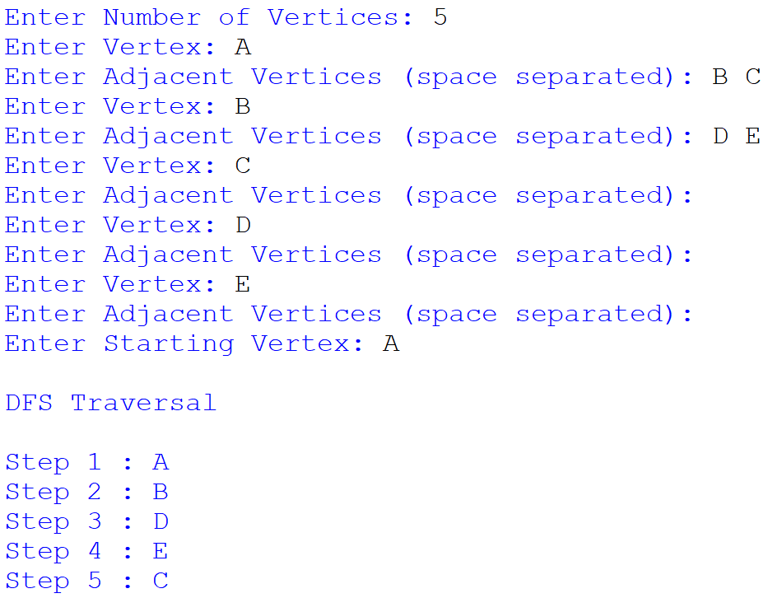
RESULTS:
Thus, the Depth-First Search (DFS) algorithm was implemented successfully, and all the reachable vertices of the graph were traversed starting from the given source vertex.

